Table of Contents
Define relational database 2
Identify major relational database menagement systems 3
Identify main characteristics of relational database 7
Understand sql’s roles in relational database 8
Recognize some indications of where a database could be useful and specify why, in this scenario, a database is needed 9
Define a statement of work for above given database scenario 11

ASSIGNMENT 1
TASK 1

DEFINE RELATIONAL DATABASE
Relational database is the type of database in which the relational data would be classify as different tables. Each table represents an entity in the database. The data of a table themselves are stored in that table. They are divided into columns and are called properties of a table. These table then define the relationships among themselves by means of repeating an attribute or column from one table in another table. These repeating columns would be called “keys”.
In the relational database, each table normally has one columns or properties assigned as a primary key. This key remarkably distinguishes each column in the table. This primary key will become a foreign key when it is shown or repeated in another table to create the relationship between the tables.
One strong point of this type of database is the redundancy is minimized. Thanks to this advantage, the chances of errors are significantly reduced and increase the protection of data integrity in the database. Nevertheless, the chief drawback of a relational database is the inherent complexity of the design.
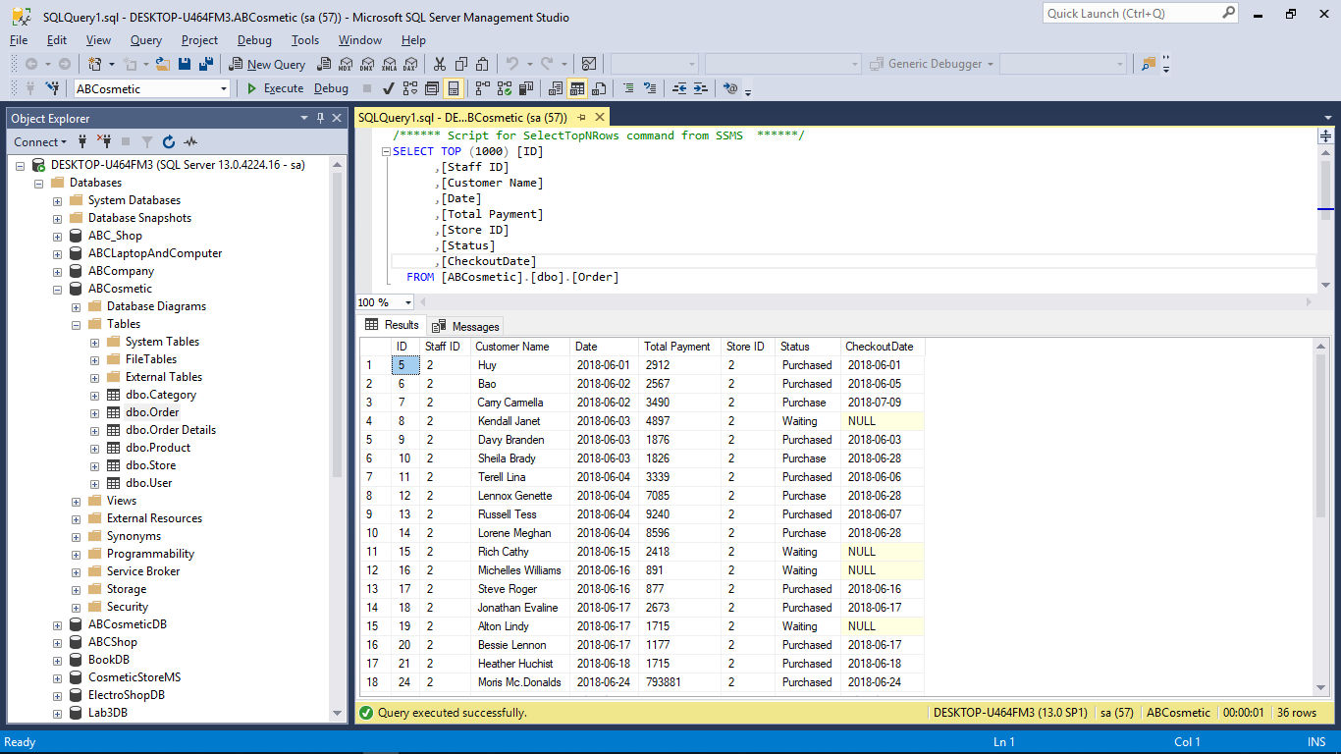
SQL Server Relational Database Manager Showing an SQL Query and Results

IDENTIFY MAJOR RELATIONAL DATABASE MENAGEMENT SYSTEMS
A relational database management system (RDBMS) is a system for managing relational databases. At a base, RDBMS needs to enable its user to create one or more databases and the objects related with that database such as tables, relationships, views and queries. Another requirement of RDBMS is the ability to support essential maintenance solutions such as backing up the database and restoring it from a back up file. In addition, RDBMS needs to provide security, guarantee that users and groups have access only to the databases and data that they are authorized to use.
Top most popular RDBMSs
RDBMS | Developer | Description
SQL Server | Microsoft | Database and analysis offering for a rapidly delivering the next generation of scalable e-commerce and line-of-business solutions.
Oracle Database | Oracle | Leading enterprise-grade relational database that offers secure data management and transaction processing.
PostgreSQL | PostgreSQL Global Development Group | Free open source post-relational database system. Leading choice by Developers and DBAs world-wide. Robust, secure, high performance.
Amazon RDS | Amazon Web Services | Web service that simplifies scaling and managing of a relational database. Support six types of database engines.
SQLite | SQLite | Database management solution in a C programming library.

SQL Server
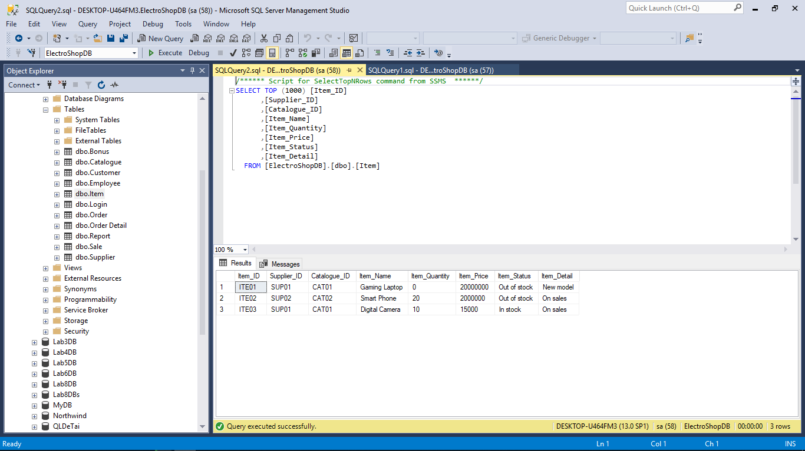
Oracle Database
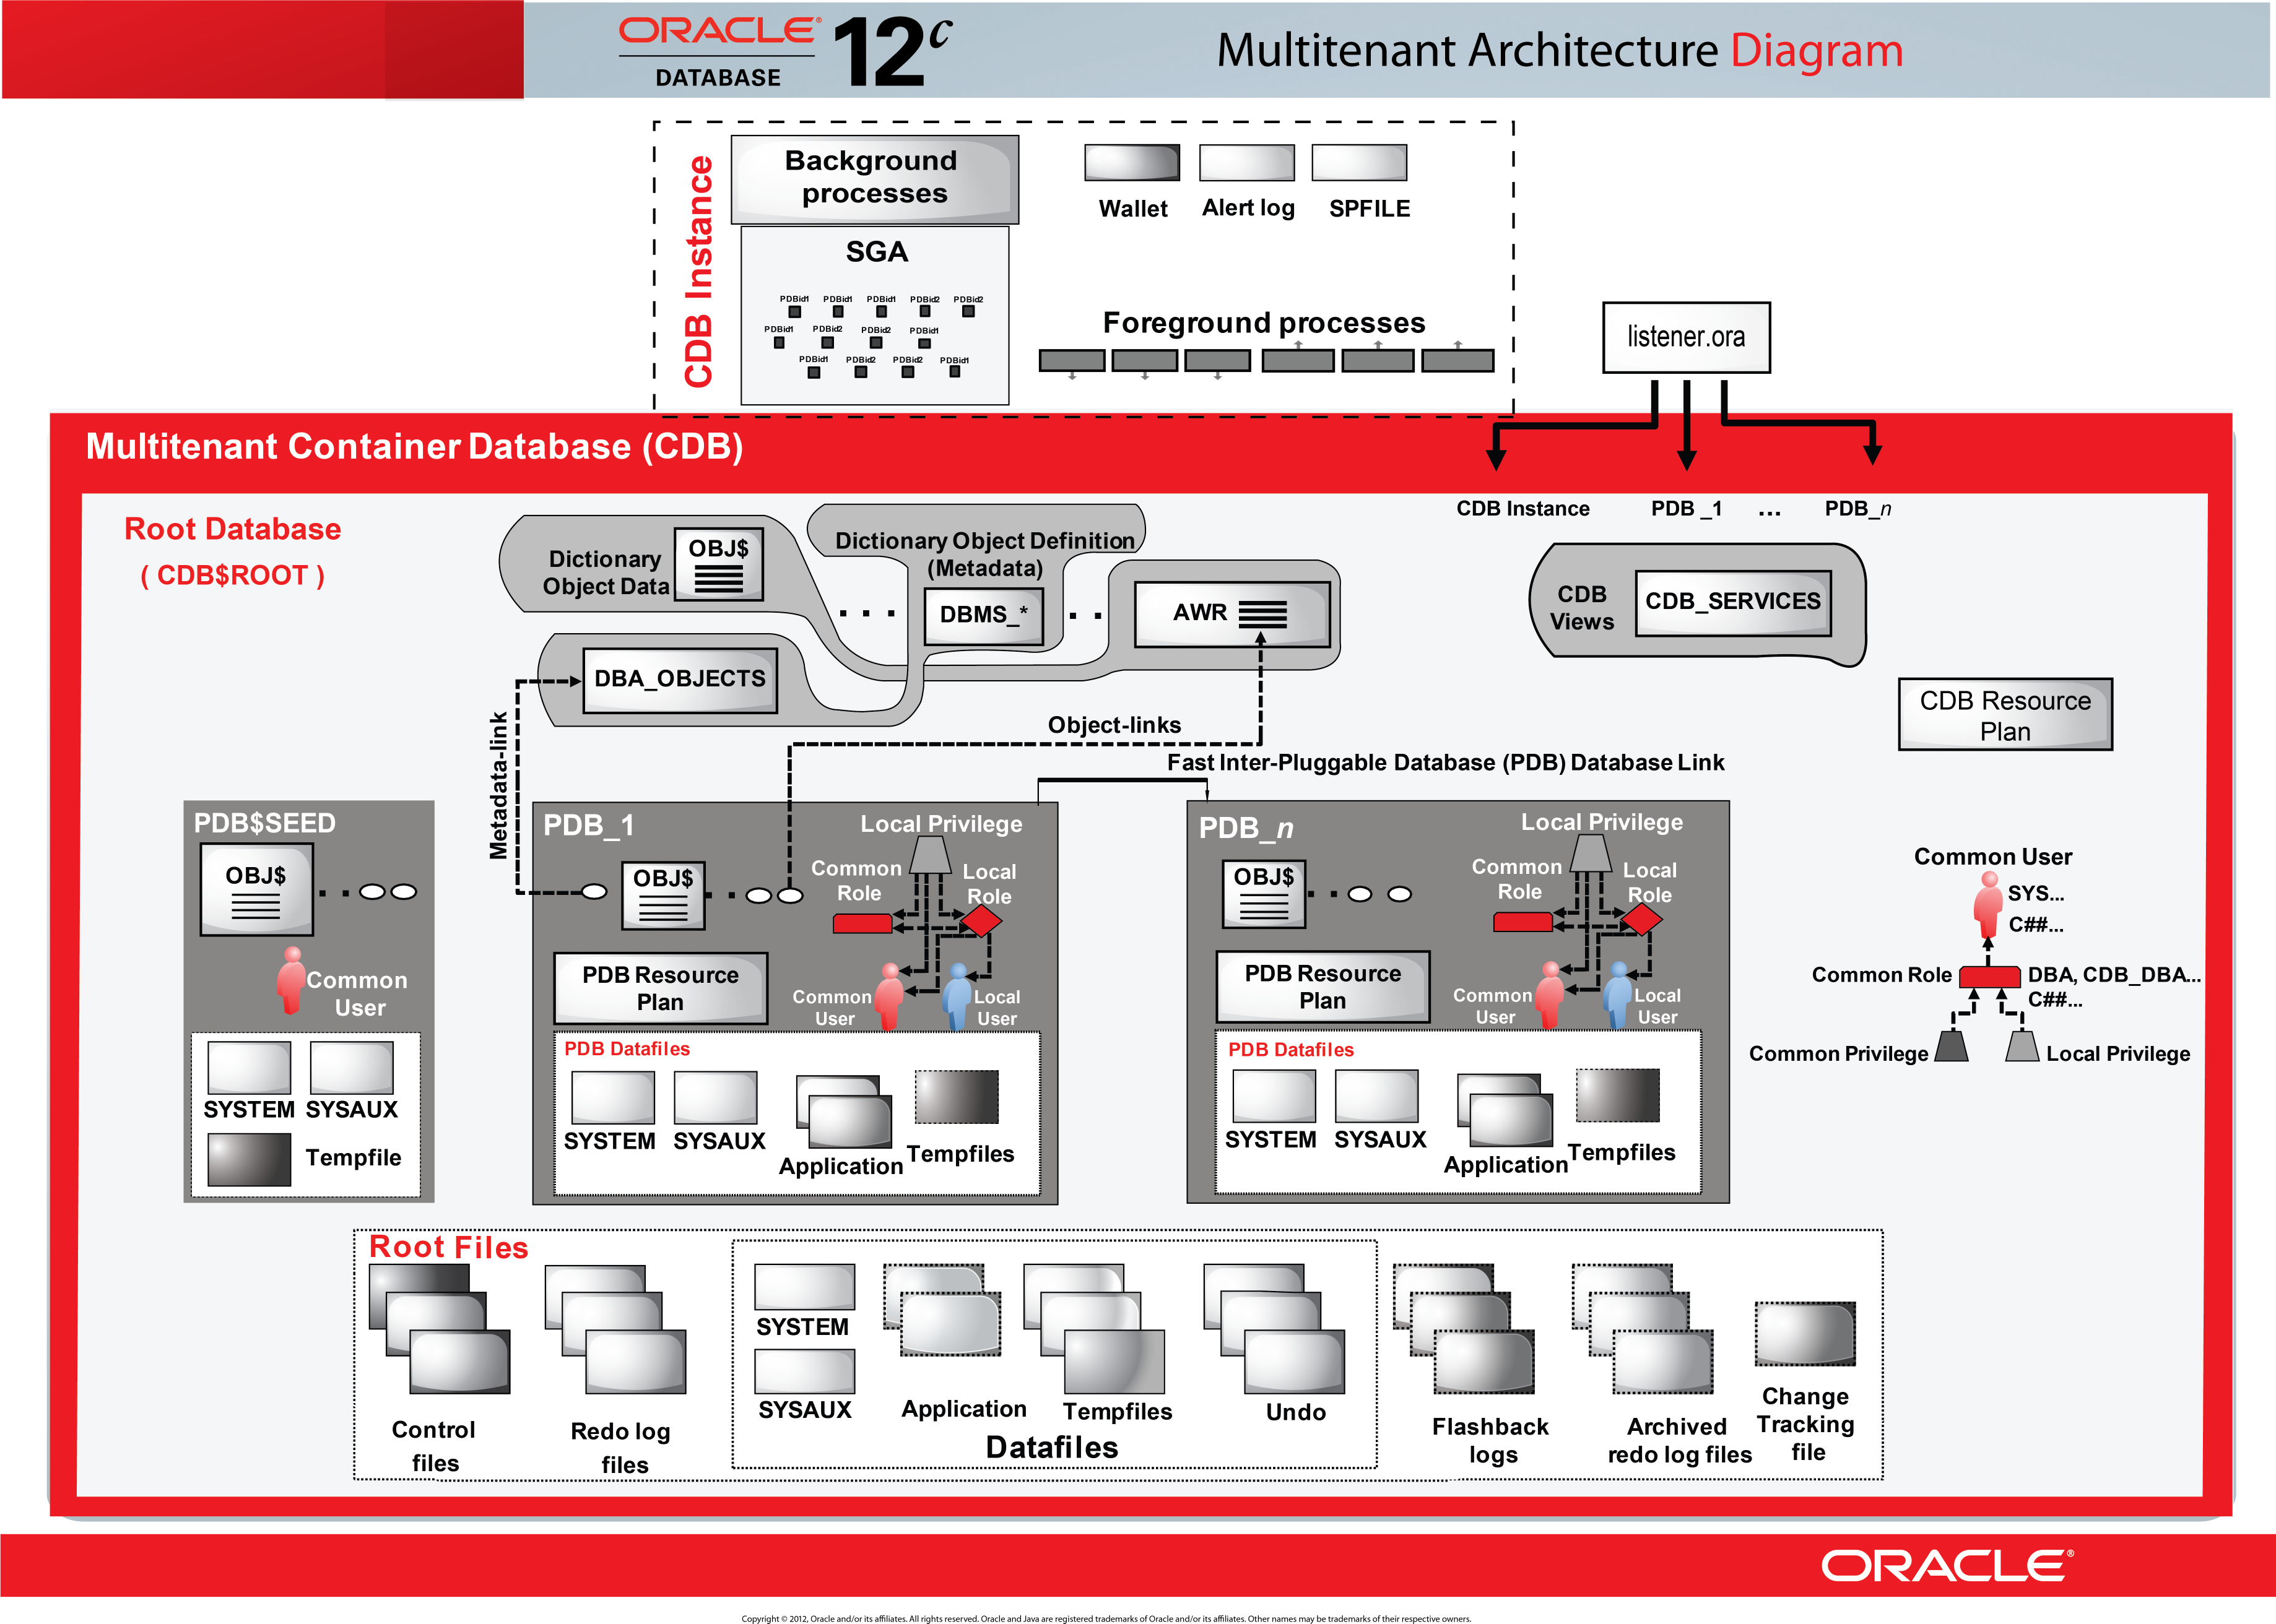
PostgreSQL
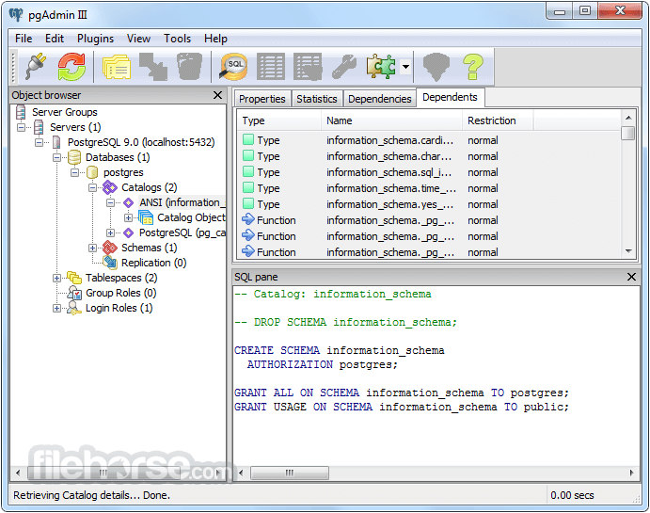
SQLite
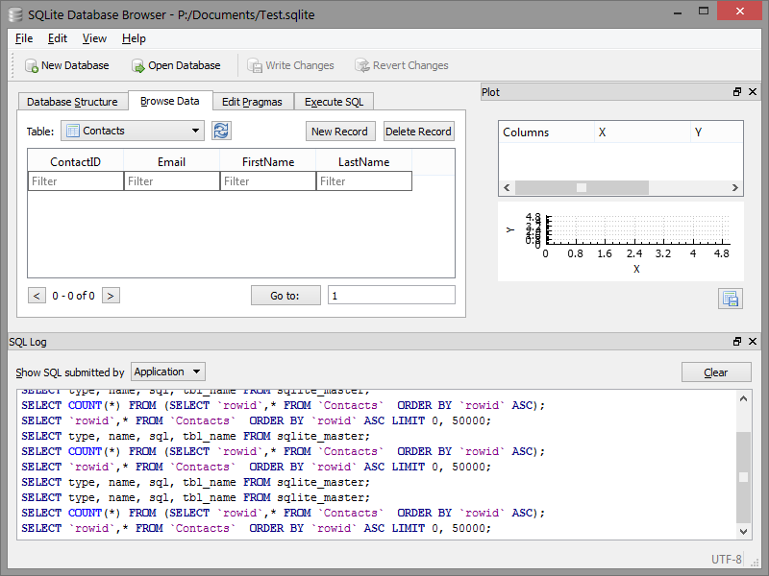

IDENTIFY MAIN CHARACTERISTICS OF RELATIONAL DATABASE
The use of keys
Each row of data in a table is identified by a unique “key”, called primary key. Data in different tables can be linked together using keys. Primary key of a table shown in others tables call foreign key.
Avoiding data redundancy
In a database design that follows the standards of the relational model, each data item is stored only once in one location. This prevents the duplication of data in multiple locations.
Constrain the input
Using a relational database, user can specify what sort of data a database column is allowed to contain. User can assign the data type for each row in integer, float, double, string, string with Unicode characters, dates, etc.
Beside data types, database system allow user to apply further constraints such as length constraints and enforcing the uniqueness of the certain field.
Maintaining data integrity
The reliability of user’s data is improved by setting field properties, linking tables and setting constraints in database system.
Structure query language (SQL)
In order to manipulate data in the database system, such as storing new data, and selecting and altering existing data, SQL queries are used. The Structure Query Language is generally straightforward and it allows advance database operations.
Portability
The relational model is a standard. By adhering the rules of the relational model, the user ensure that the user’s data can be transferred between relational database systems relatively easily.
Security
According to (techspirited.com, n.d.), relational databases provide excellent security. They support access permissions which allow the database administrator to implement need-based permissions to the access of data in database tables. Relational databases support the concept of users and user rights, thus meeting the security needs of databases. Relations are associated with privileges like create privilege, grant privilege, select, insert, and delete privileges, which authorize different users for corresponding operations on the database.

UNDERSTAND SQL’S ROLES IN RELATIONAL DATABASE
SQL language plays an important role in relational database management system. The use of SQL includes modifying database table and index structures; adding, updating and deleting rows of data; and retrieving subsets of information from within a database for transaction processing and analytics applications. Queries and other SQL operations take the form of commands written as statements, commonly used SQL statements include select, add, insert, update, delete, create, alter and truncate.
SQL is intensively employed to control all important functions a user can perform through a database management system, including:
- Data definition
- Data retrieval
- Data manipulation
- Access control
- Data sharing
- Data integrity
SQL is, therefore, a comprehensive language and a resourceful, powerful tool to control and interact with a computer database system.

RECOGNIZE SOME INDICATIONS OF WHERE A DATABASE COULD BE USEFUL AND SPECIFY WHY, IN THIS SCENARIO, A DATABASE IS NEEDED
There are many situations that could be improved with an addition of a database. Whenever there is a large amount of complex data to handle, a database is likely to provide the best solution.
Managing information means taking care of it so that it works for us and it is useful for the tasks we perform. By using a DBMS, the information we collect and add to its database is no longer subject to accidental disorganization. It become more accessible and integrated with the rest of our works. Managing information using a database allows us to become strategic users of the data we have.
The processing power of a database allows it to manipulate the data it houses, so it can:
- Sort
- Match
- Link
- Aggregate
- Skip fields
- Calculate
- Arrange
Advantages of relational database
- Ease of use: easier to understand as information are represented as tables with rows and columns.
- Flexibility: information can be retrieved and processed from different tables which are linked together.
- Precision: the usage of relational algebra and relational calculus in the manipulation of the relationships between the tables ensures that there is no ambiguity.
- Security: security control and authorization can also be implemented more easily by moving sensitive attributes in a given table into a separate relation with its own authorization control.
- Data independence: relational database uses normalization will help to achieve data independence more easily.
- Data integrity: the reliability of user’s data is improved by setting field properties, linking tables and setting constraints in database system.
- Data manipulation language: the possibility of responding to query by means of a language based on relational algebra and relational calculus such as SQL is easy in the relational database approach.
Disadvantages of relational database
- The machine performance can be affected by large number of tables between which relationships to be established and the table themselves.
- Physical storage consumption can limit the frequency of the database operations since relational database is an interactive system.
- Slow extraction of meaning from data. if the data is naturally organized in a hierarchical manner and stored as such, the hierarchical approach may give quick meaning for that data.
Explain why database is needed in the given scenario
In this scenario, ElectroShop is a company who acquire and sell electronic devices to customers throughout Vietnam. The company desires to manage their huge amount of information in various of the company aspects from the product categories, product types to customers’ orders and staffs’ sales in each month. In order to solve the problem of controlling all the data of the company in the most convenience and secured method, a relational database is needed.

DEFINE A STATEMENT OF WORK FOR ABOVE GIVEN DATABASE SCENARIO
History
ElectroShop is a company who acquire and sell electronic devices to customer throughout Vietnam. They are looking to apply their current data store system with a relational database.
The company takes orders from customers, who can order any quantity of many items that ElectroShop have in their current catalogue. The catalogue includes TV, Phone, etc.
Each ElectroShop’s suppliers supplies many items but each item is supplied by one main supplier.
ElectroShop would like to add all the customers to the database so that they can a mail-shot to them with any offers that are available, as well as the catalogue which is produced annually.
Salespersons at ElectroShop are paid a monthly bonus which is determined by the amount of sales they have made for each month. The company would like the bonus calculated automatically by the system.
As well as the monthly bonus figures ElectroShop would like to be able to create comparatives reports from the system i.e. sales figures for each month this year compared to last year.
A relational database with integrated interactive program for user can be an effective solution to meet the company’s demands by providing the secured and flexible methods for storing and manipulating information as well as the ability to automatically generate reports as the company’s requirements.
Scope
The relational database system will manage data for ElectroShop company in the business of selling electronic devices throughout Vietnam. This system will store all the information of the company in the relational database. These data will be divided into separated tables based on the company’s business specification.
The database will manage the number of suppliers corporate with the company as well as their supplying items. The company can keep track on the products list base on the type of catalogues, the prices, the quantities, etc. of the products available in the database. Another benefit of relational database in this scenario is the control of the customers’ information and orders in order to send offer messages.
The main target to archive when implementing relational database in this scenario is the function to automatically calculate the monthly bonus for the staffs via the monthly sales of staffs recorded in the database. The database will keep track on all the transactions made by staff so it can add precise bonus for each staff. Base on the monthly bonus statistics of staffs, the database can produce reports for each month this year to compare with last year.
Objectives
Store all the company’s customers in the database so that the company can send a mail-shot with any offers that are available, as well as the catalogue which is produced annually.
Automatically calculate the monthly bonus of salespersons base on the amount of sales made in each month.
Create comparative reports from system i.e. sales figures for each month this year compare to last year.
Tasks and Timeline
- Gathering data: the main activities in this task is to collect information the company wishes to store in the database. Time allotted: 2 weeks. Deliverable: list of company data model.
- Analyzing data: at this stage, data gathered will be analyzed to determine business rules and preliminary data modeling. Time allotted: 1 week. Deliverable: list of business rules to be reviewed.
- Normalization: the data model will be completed with entities and relationships normalized. Time allotted: 3 days. Deliverable: entity relation diagram for review.
- Building the physical database: relational database management system will be implemented based on the data model. Specific data types together with their relationships and others constraints created will be referred as tables’ columns. Time allotted: 2 days. Deliverable: the schema of the database for review.
- Testing and security: this stage mainly carries out test plan on business rules and requirements based on the input sample data. This process also ensures the security of the general database as well as security related to the business rules. Time allotted: 2 weeks. Deliverable: documented test results.
- Database completion and installation: real-time implementation of the designed database on a working server with actual data entered. Final testing for server access and connections. Time allotted: 1 week. Deliverable: the functional database.

References
Capterra.com, n.d. RDBMS Software. [Online]
Available at: https://www.capterra.com/rdbms-software/
[Accessed 25 September 2018].
Freeasphosting.net, n.d. The Role of SQL. [Online]
Available at: https://freeasphosting.net/sql-tutorial-sql-role.html
[Accessed 25 September 2018].
http://maxlogix.blogspot.com, n.d. Advantages and Disadvantages of using relational databases. [Online]
Available at: http://maxlogix.blogspot.com/2009/09/advantages-and-disadvantages-of-using.html
[Accessed 25 September 2018].
searchsqlserver.techtarget.com, n.d. SQL (Structured Query Language). [Online]
Available at: https://searchsqlserver.techtarget.com/definition/SQL
[Accessed 25 September 2018].
techspirited.com, n.d. Advantages of Relational Databases. [Online]
Available at: Relational databases provide excellent security. They support access permissions which allow the database administrator to implement need-based permissions to the access of data in database tables. Relational databases support the concept of users and use
[Accessed 9 October 2018].
Tekstenuitleg.net, n.d. Relational database characteristics. [Online]
Available at: http://en.tekstenuitleg.net/articles/software/database-design-tutorial/database-characteristics.html
[Accessed 25 September 2018].
Watt, A., n.d. Chapter 3 Characteristics and Benefits of a Database. [Online]
Available at: opentextbc.ca/dbdesign01/chapter/chapter-3-characteristics-and-benefits-of-a-database/
[Accessed 25 September 2018].

END OF ASSIGNMENT 1

